# **Practical:1**

**Name:**

**Roll No:**

**Class: BCA-III**

**Subject: Emerging Trends & Database.**

**QUE**: **How to run MongoDB shell?**

**Step1:** For running Mongodb shell we have to install Mongodb compass and Mongodb shell.

**Step2:** After installing Mongodb shell open command prompt and enter Mongod space—version press enter.

**Step3:** Then enter command for Mongosh.

**Step4:** Use command to see already created databases

i.e.show dbs press enter.

**Step5:** Now we want to create new database then type ‘use database name’ command e.g if you want to create new database named BCA-III then type Use BCA-III press enter .

**Step6**: Finally you running Mongodb shell with newly created database named BCA-III.

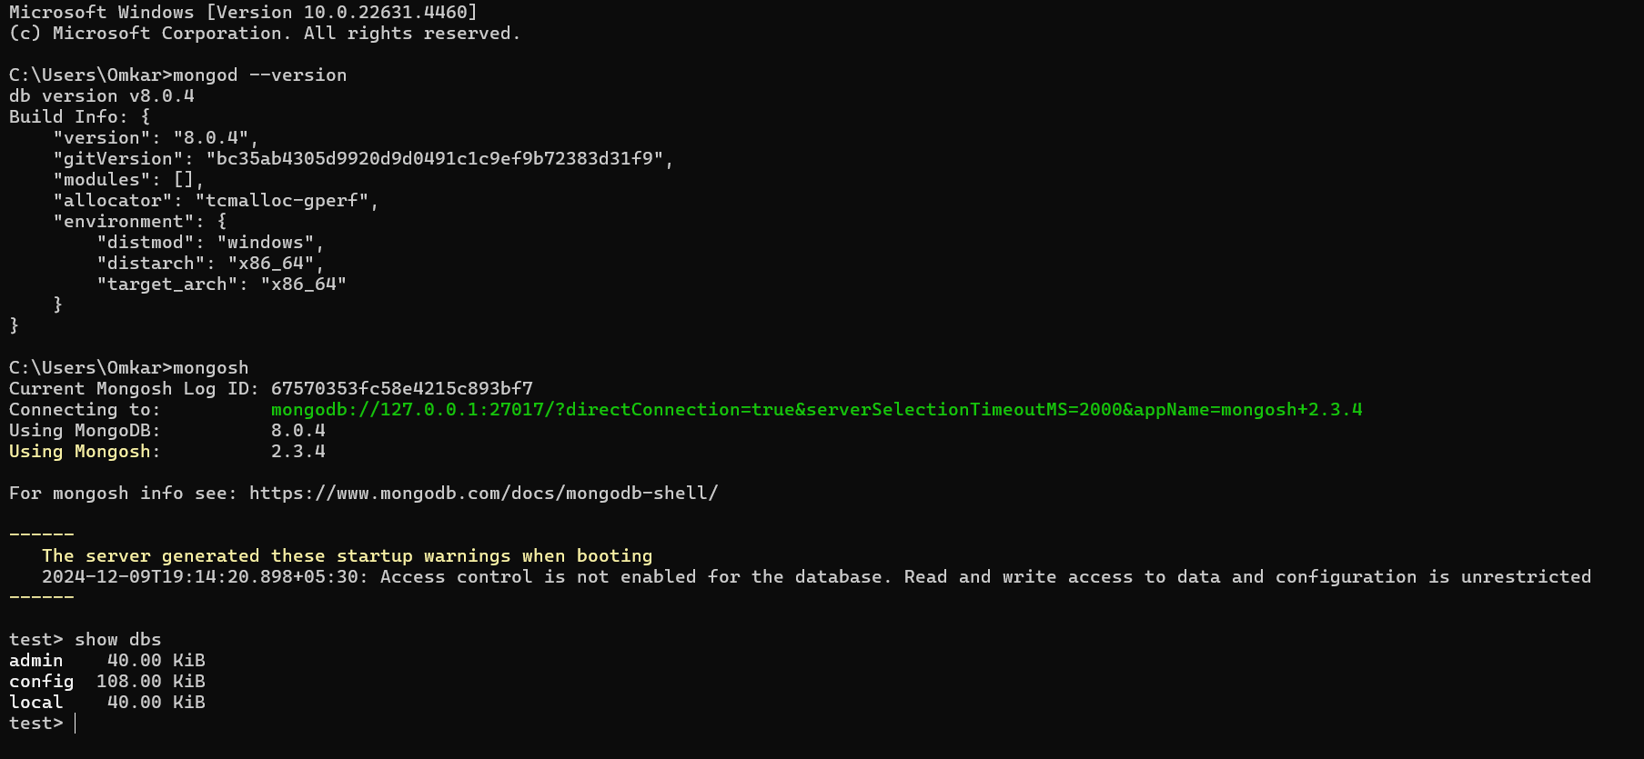

# **Practical:2**

**Name:**

**Roll No:**

**Class: BCA-III**

**Subject: Emerging Trends & Database.**

**QUE: Basic operations of MongoDB Shell (CRUD).**

1.create database

And insert objects. 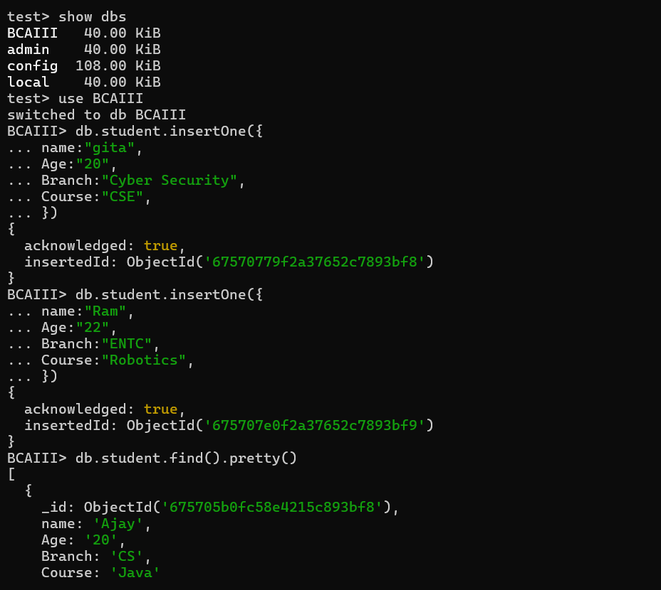

2.show all

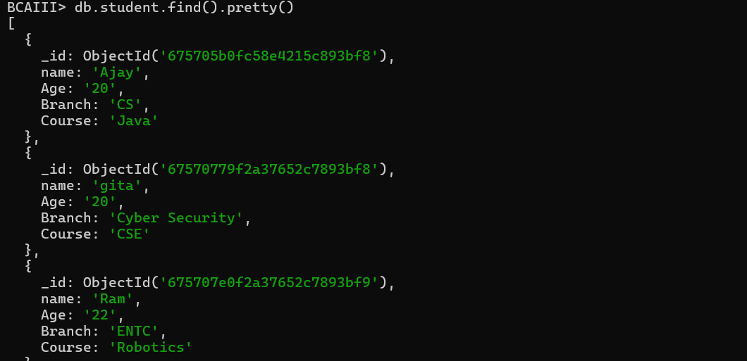

3.update

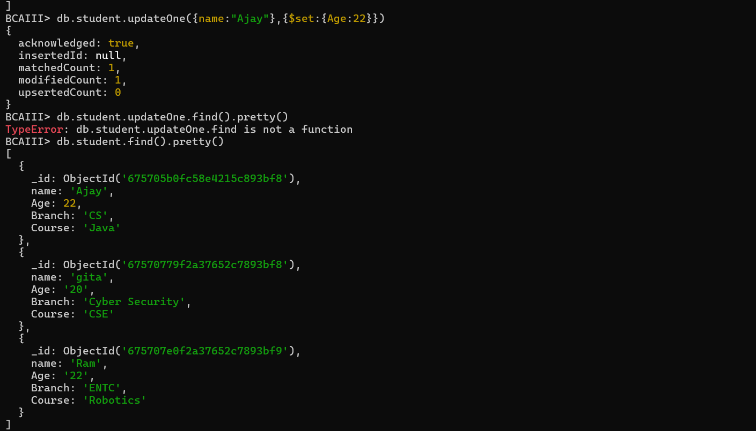

# **Practical:3**

**Name:**

**Roll No:**

**Class: BCA-III**

**Subject: Emerging Trends & Database.**

**QUE: Basic operation Using MongoDB Compass (CRUD).**

1)create database

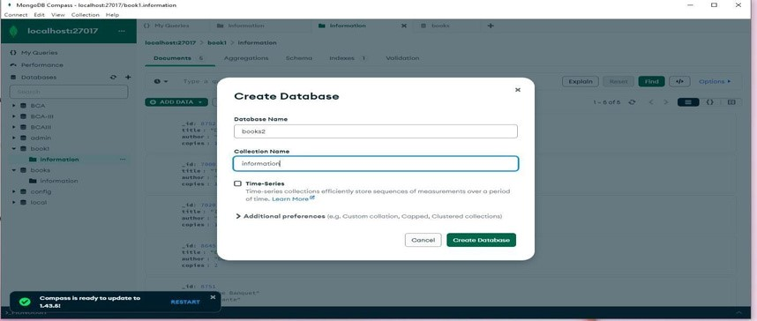

2)insert data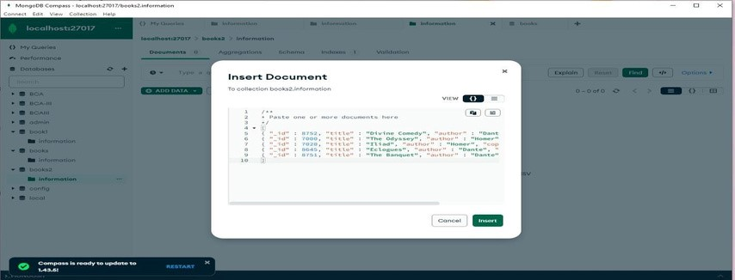

3)Read database

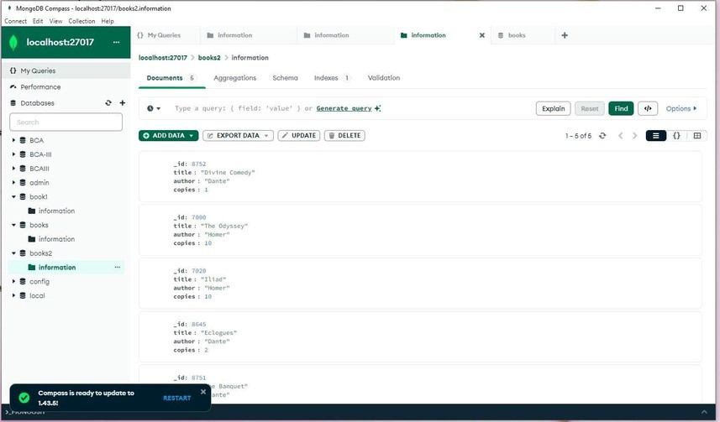

4)update

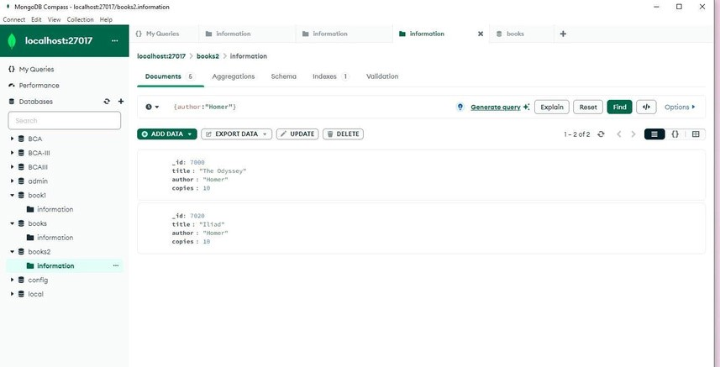

5) Delete

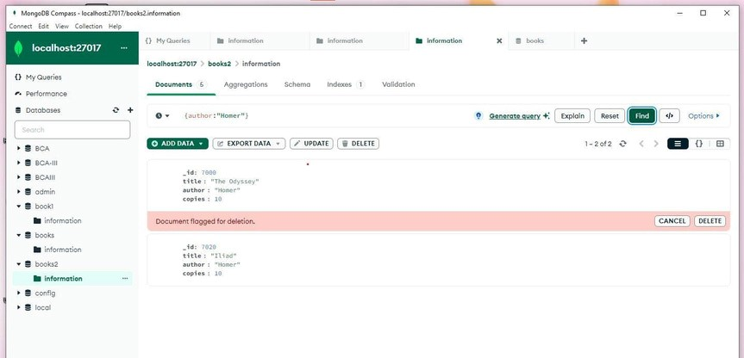

# **Practical:4**

**Name:**

**Roll No:**

**Class: BCA-III**

**Subject: Emerging Trends & Database.**



**Q.4.Aggregation Pipeline Example in MongoDB.**

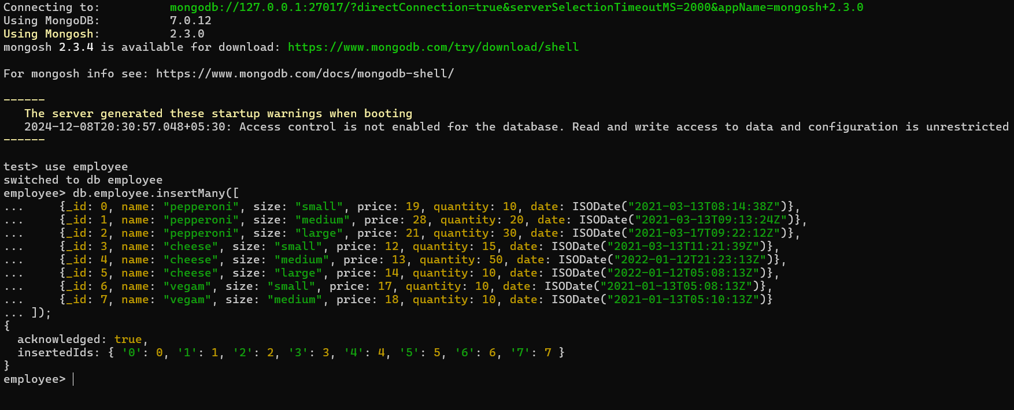

**Calculate Total Order Quantity:  
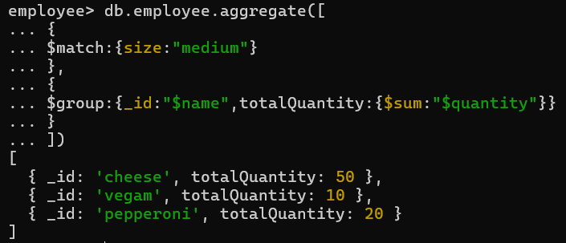**

Experiment no :5

**Calculate Total Order Value and Average Order Quantity:**

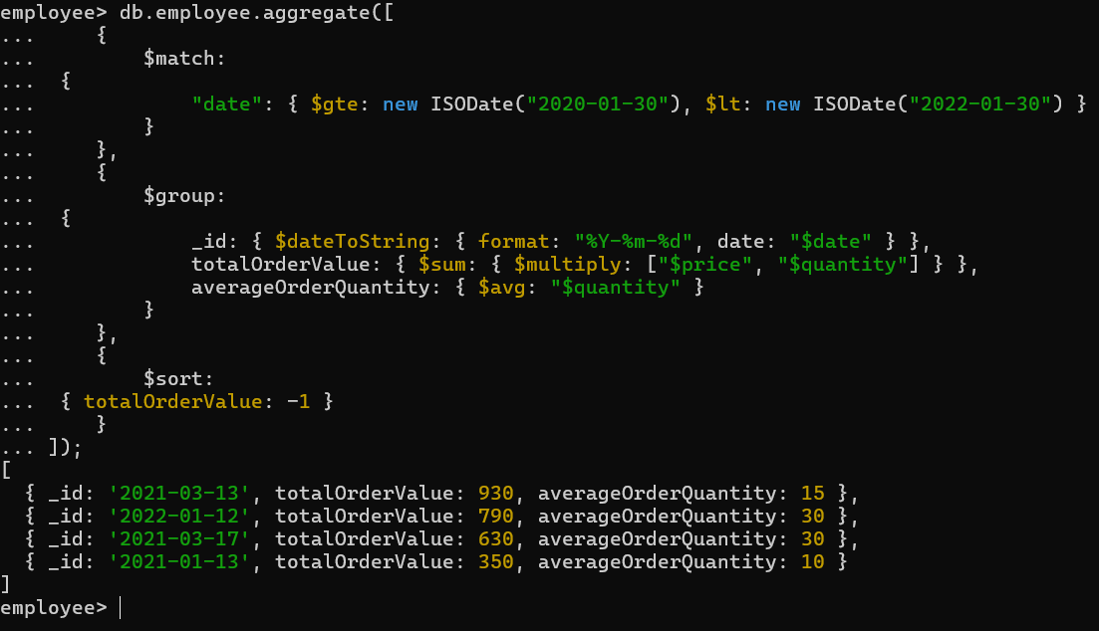

# **Practical:5**

**Name:**

**Roll No:  
Class: BCA-III**  
**Subject: Emerging Trends & Database.**

Q. Querying With MongoDB

Creating a data base Knowledge.

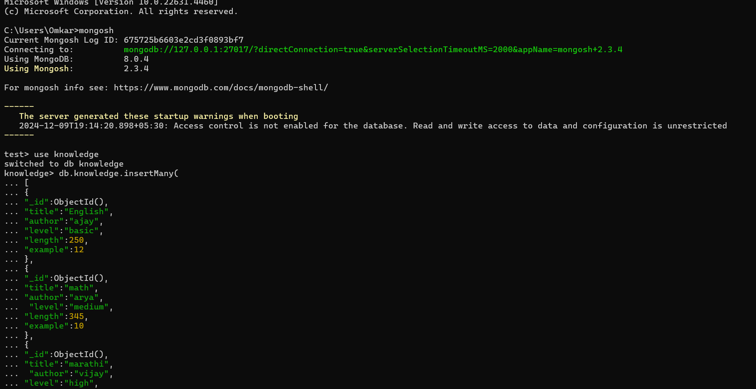

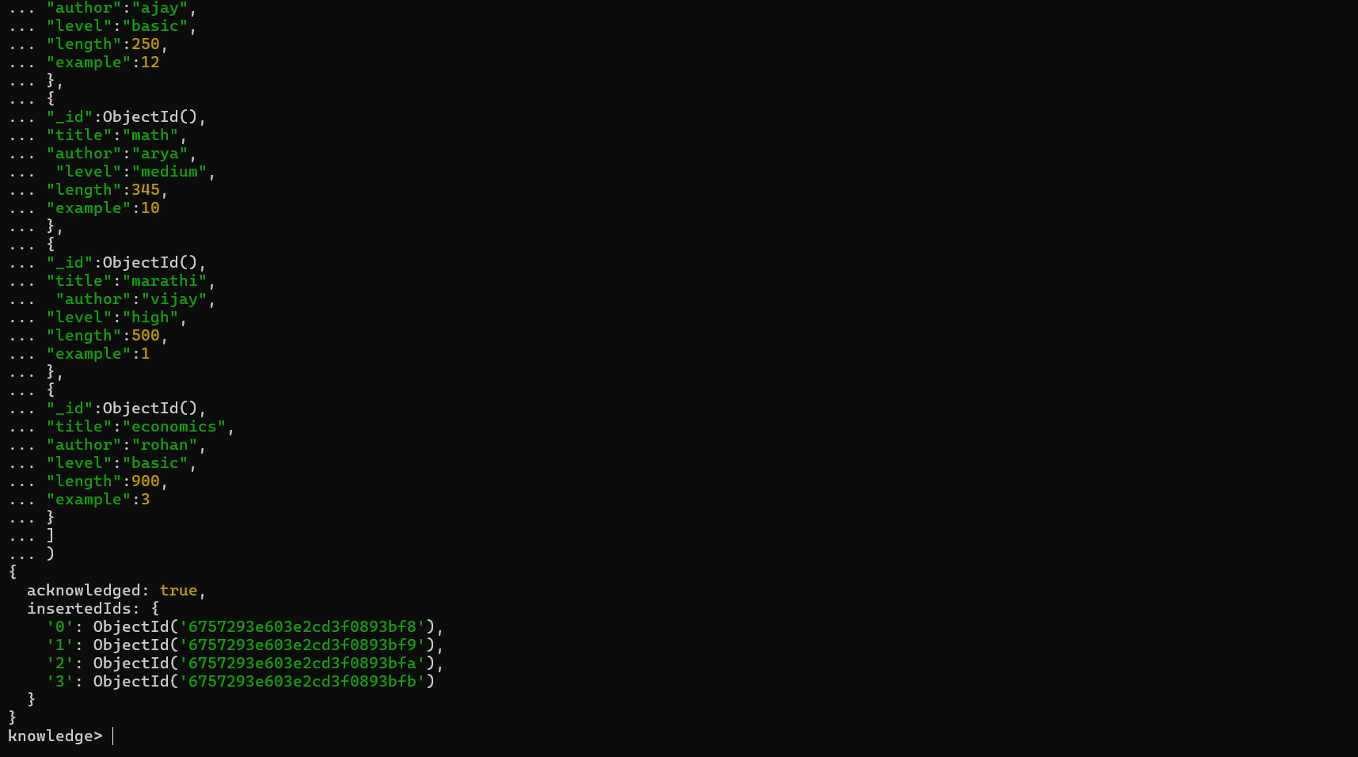

1.Selecting Single Document From a knowledge

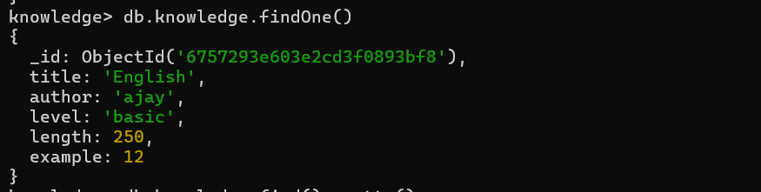

2.Selcting all documents in a knowledge

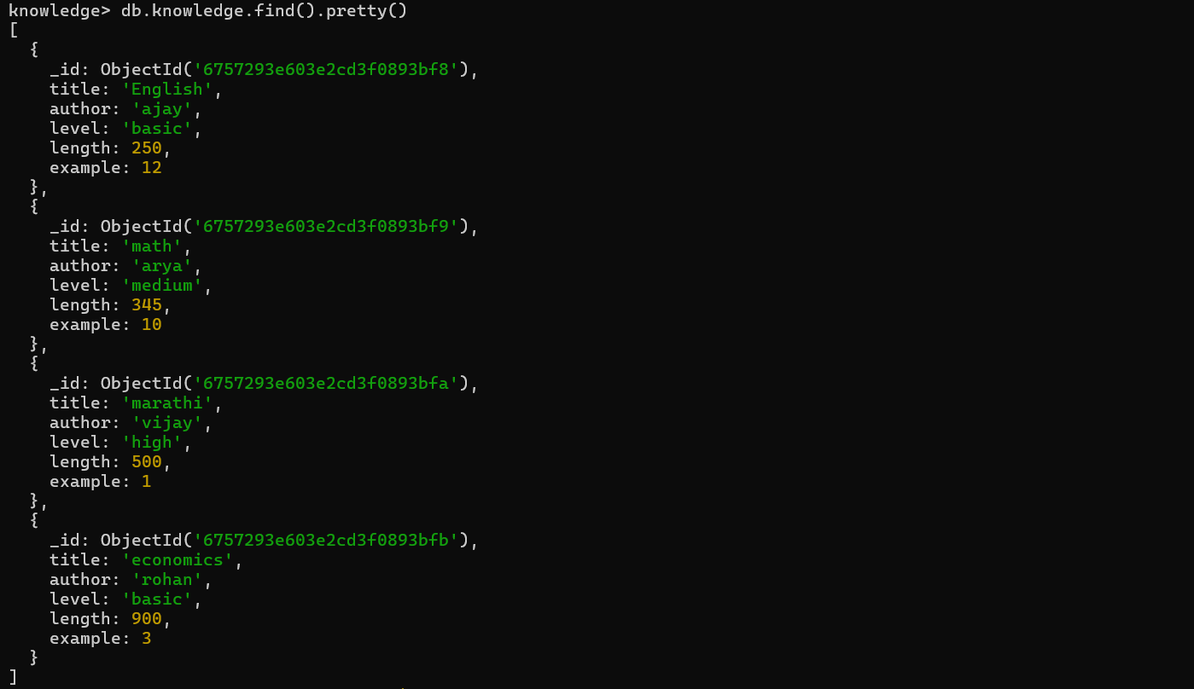

3.Specify Equality Condition($eq).

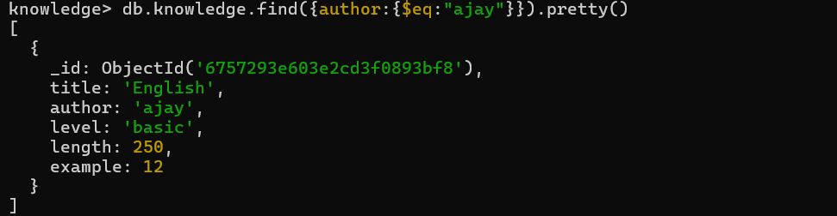

4.Greater than Filter Query($gte or $ite).

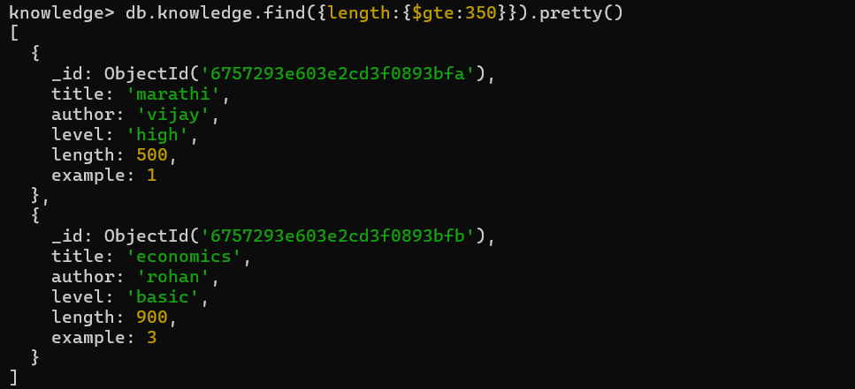

5.less than Query

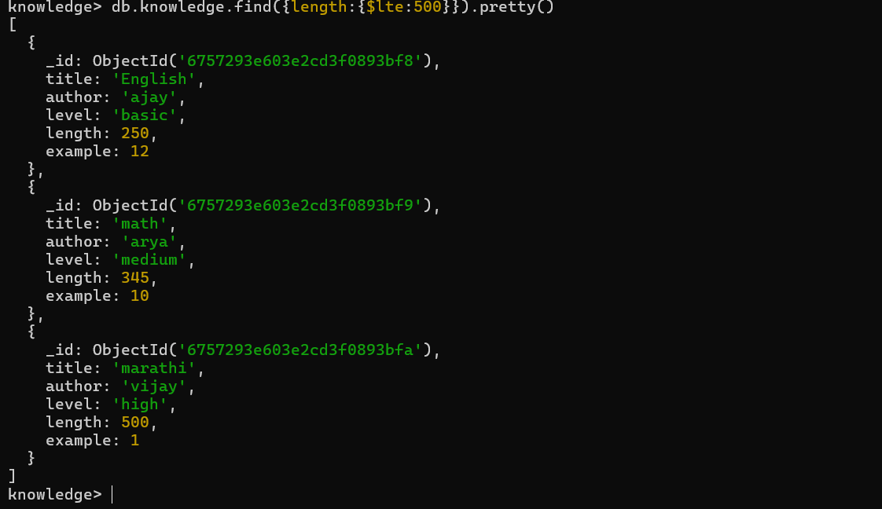

# **Practical:6**

**Name:   
Roll No:**  
**Class: BCA-III**  
 **Subject: Emerging Trends & Database.**





Specify AND Condition ($And)

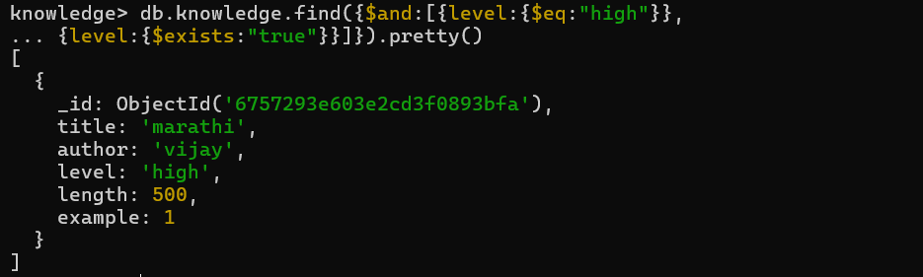

Specify AND and OR Condition

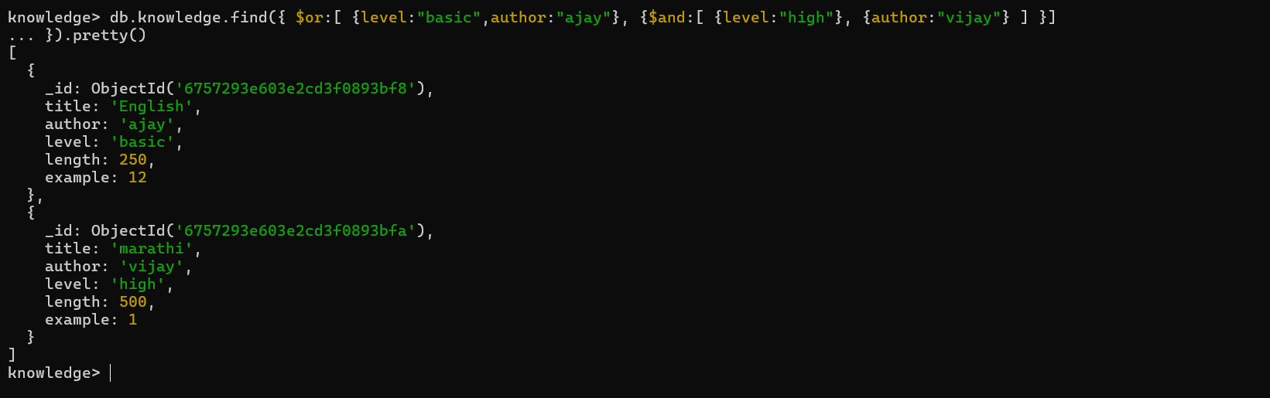

Limit the Query(Limit(value))

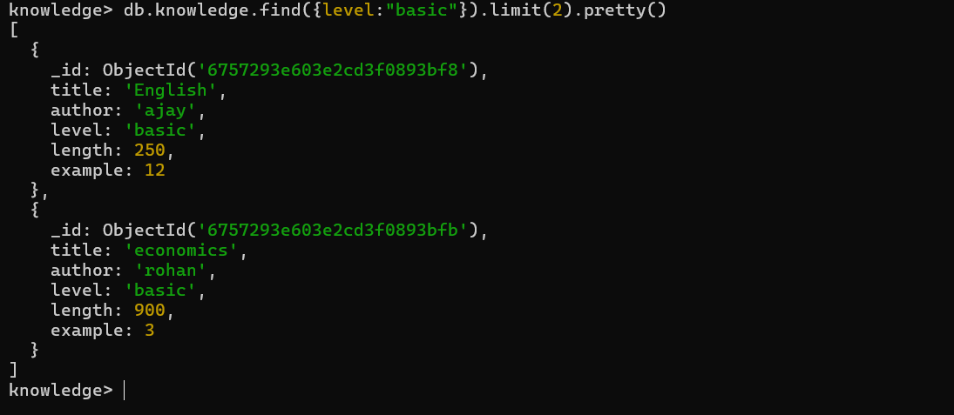

# **Practical:7**

**Name:   
Roll No:**  
**Class: BCA-III**  
 **Subject: Emerging Trends & Database.**

Q.7. MongoDB $type operator example  
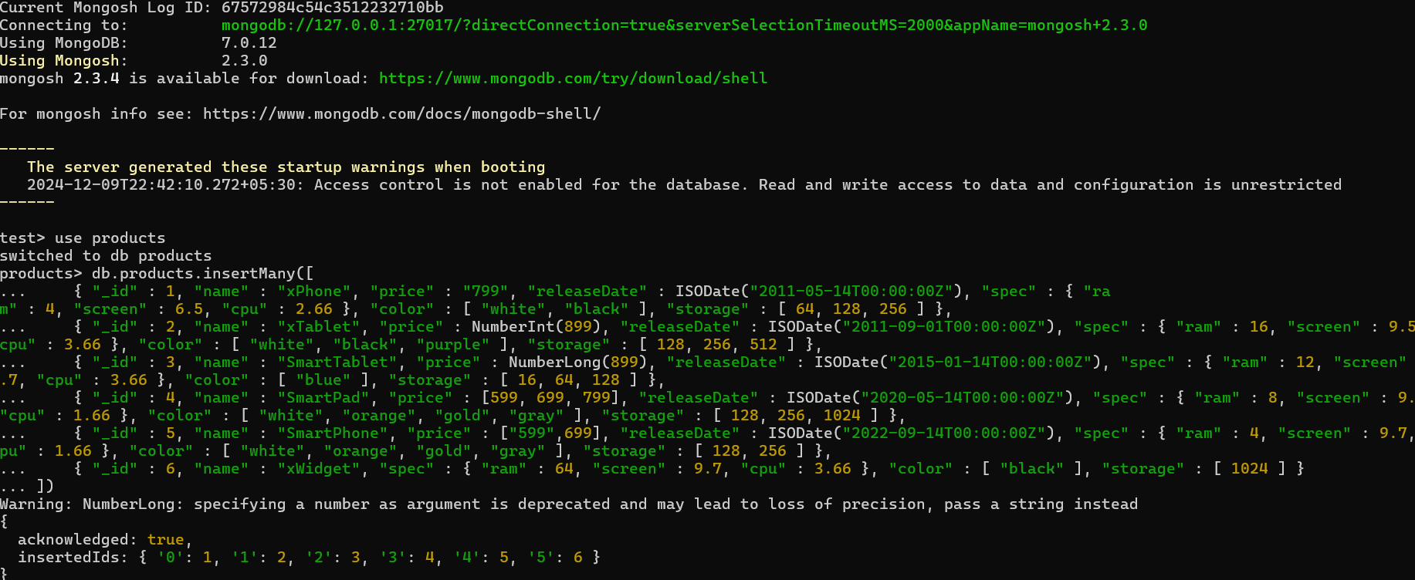

1) Using the $type operator example

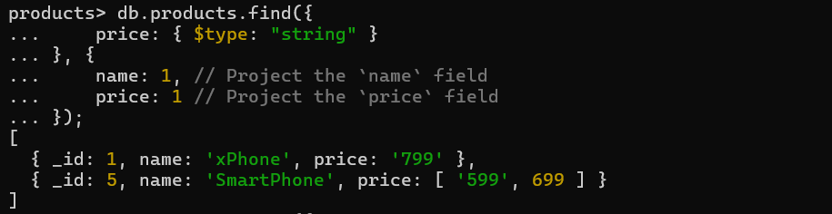

2) Using the $type operator with the number alias example

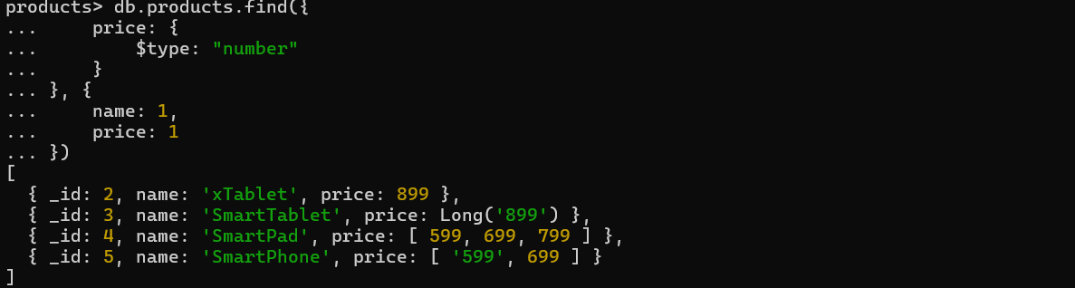

3) Using the $type operator to query documents with array type example



4) Using the $type operator to query documents with multiple types

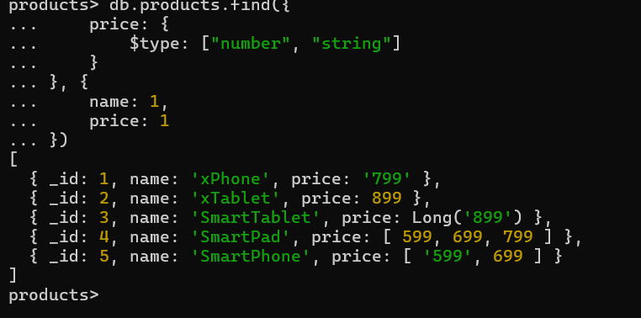

# **Practical:8**

**Name:   
Roll No:**  
**Class: BCA-III**  
 **Subject: Emerging Trends & Database.**

Que. Performing queries on given collection.

Structure of restaurant collection.

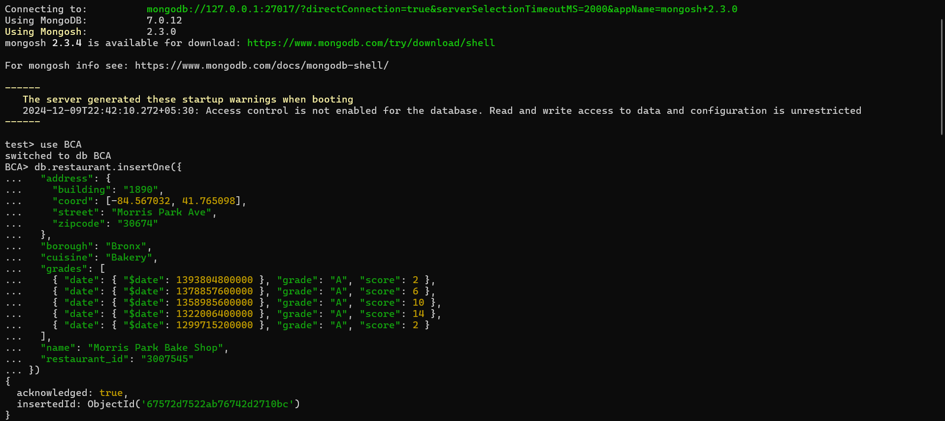

Queries:

1.Write a MongoDB query to display all the document in the collection restaurant. 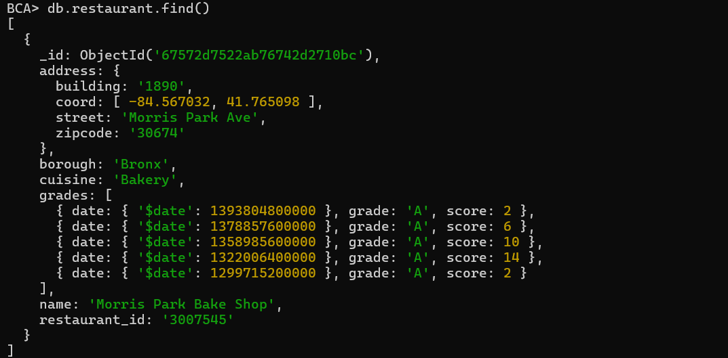

2.write a MongoDB query to display the fields restaurant_id ,name,borough and cuisins for all the document in the collection restaurant.

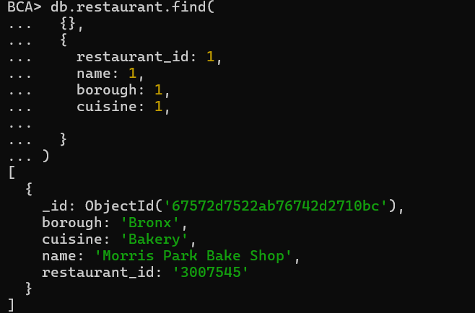

3.write a MongoDB query to find the restaurant who achieve a score more than 90

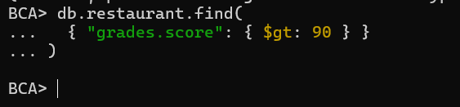

4. Write a MongoDB query to display first 5 restaurant which is the borough Bronx

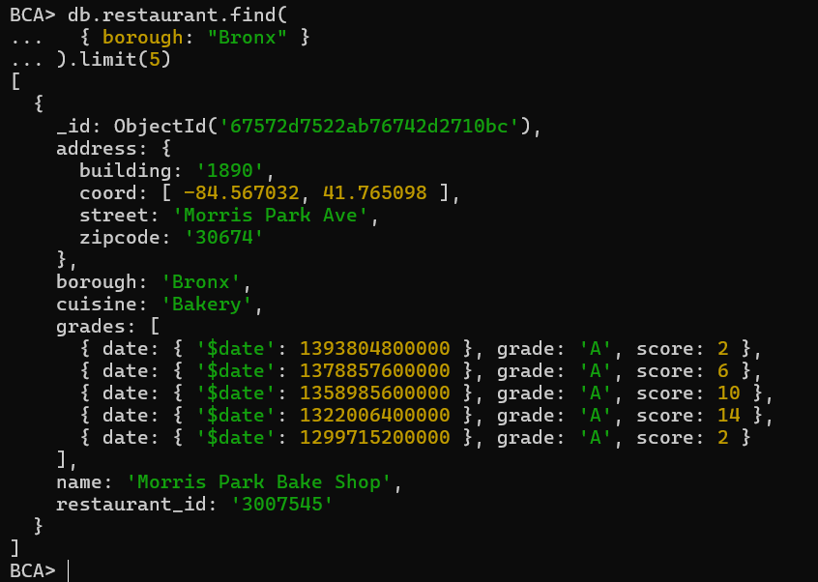

5. Write a MongoDB query to display next 5 restaurant after skipping first 5 which are in borough Bronx

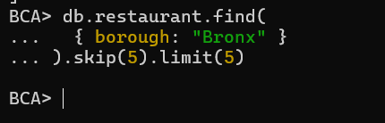

# **Practical:9**

**Name:**

**Roll No:**

**Class: BCA-III**

**Subject: Emerging Trends & Database.**



Que. MongoDB index

Collection which are using for indexing.

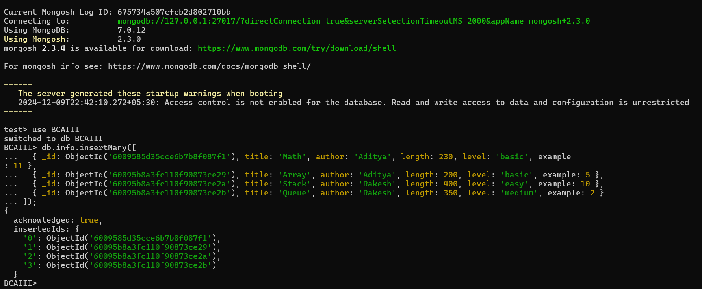

Queries:  
1.Create ascending index on a single field.  


2. Create descending index on a single field.



3.Create an index on multiple fields



4.Creating a unique index using option

